Famous Labradors of the Past & Present
Dual Ch. Banchory Bolo
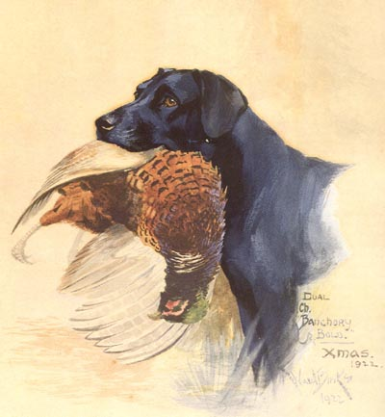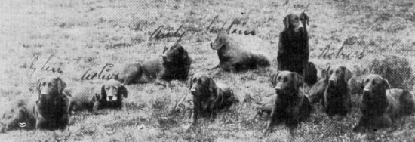
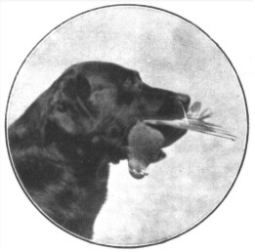
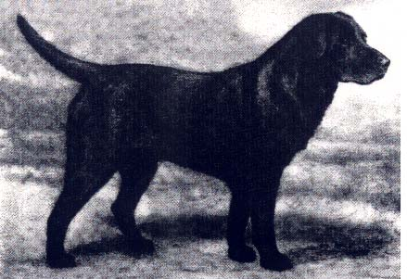
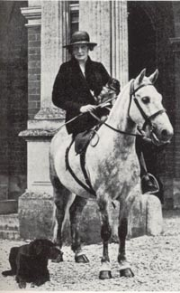
Lady Howe with Banchory Bolo
.
DOB | 12 / 1915
Color |  | BxEx | B
Sex | dog
Titles | Dual Champion
Affix | Banchory

Children of Banchory Bolo
 |  |  |  |  | Sire | Dam
 | ? | < 1919 |  | Banchory Drift | Banchory Bolo | Brocklehirst Nell
 | M | 1920 | F.T.W. | Bale | Banchory Bolo | Banchory Queen
 | F | < 1920 |  | Seal Of Lund | Banchory Bolo | Banchory Queen
 | M | 1921 | F.T.W. | Alconbury Daniel | Banchory Bolo | Euston Darkie
 | M | 1921 |  | Banchory Bluff | Banchory Bolo | Brocklehirst Nell
 | M | 1921 | C.C.W., F.T.W. | Banchory Corbie | Banchory Bolo | Kirkmahoe Dina
 | F | 1921 | F.T.W. | Banchory Primula | Banchory Bolo | Thyme
 | M | 1921 | CH-ANG F.T.W. | Beningbrough Tangle | Banchory Bolo | Thyme
 | F | 1921 | C.C.W., F.T.W. | Brocklehirst Daisy | Banchory Bolo | Brocklehirst Nell
 | M | 1921 | CH-ANG F.T.W. | Brocklehirst Donner | Banchory Bolo | Murrayfield Bett
 | F | 1921 | F.T.W. | Choice Of Kirkmahoe | Banchory Bolo | Kirkmahoe Dina
 | F | 1921 | F.T.W. | Fintry Joy | Banchory Bolo | Kirkmahoe Dina
 | M | 1921 | F.T.CH-ANG | Kirkmahoe Rover | Banchory Bolo | Kirkmahoe Dina
 | M | 1921 | F.T.W. | Larkie | Banchory Bolo | Euston Darkie
 | F | < 1921 |  | Murrayfield Patsy | Banchory Bolo | Kirkmahoe Dina
 | F | < 1921 |  | Selling Plate | Banchory Bolo | Sable Snake
 | F | 1921 | F.T.W. | Sheila Of Gledstone | Banchory Bolo | Banchory Queen
 | M | 1921 | F.T.W. | St. Mary's Dick | Banchory Bolo | Murrayfield Bett
 | M | 1921 | F.T.W. | Volo Of Glynn | Banchory Bolo | Banchory Mint
 | F | 1921 | F.T.W. | Weston Bangle | Banchory Bolo | Thyme
 | M | 1921 |  | Banchory Jock | Banchory Bolo | Brocklehirst Nell
 | F | 1922 | CH-ANG | Banchory Kelpie | Banchory Bolo | Malta Of Lunn
 | F | 1922 | F.T.W. | Banchory Music | Banchory Bolo | Malta Of Lunn
 | F | 1922 | F.T.W. | Banchory Plover | Banchory Bolo | Banchory Widgeon
 | M | 1922 | F.T.CH-ANG | Nith Of Halleaths | Banchory Bolo | Brocklehirst Nell
 | F | 1922 | F.T.W. | Sopwell Bustle | Banchory Bolo | Trance Of Whitmore
 | M | 1923 | CH-ANG F.T.W. | Banchory Danilo | Banchory Bolo | Munden Scarcity
 | M | 1923 | F.T.W. | Banchory Roger | Banchory Bolo | Patience Of Faskally
 | M | 1923 |  | Fearless Of Flodden | Banchory Bolo | Guinea
 | F | 1923 | F.T.W. | Iwerne Minster Boeloe | Banchory Bolo | Munden Scarcity
 | F | 1923 | F.T.W. | Lochar Kate | Banchory Bolo | Murrayfield Bett
 | F | 1923 | F.T.W. | Munden Singer | Banchory Bolo | Munden Scarcity
 | M | 1923 | F.T.W. | Munden Solo | Banchory Bolo | Munden Scarcity
 | F | 1923 |  | Wolferton Solo | Banchory Bolo | Munden Scarcity
 | F | < 1925 |  | Banchory Nettle | Banchory Bolo | Murrayfield Bett
 | ? | < 1925 |  | Banchory Nettler | Banchory Bolo | Banchory Patsy
 | M | < 1925 | C.C.W. | Beningbrough Teddy | Banchory Bolo | Thyme
 | F | < 1925 |  | Withington Lodo | Banchory Bolo | Dungavel Dance
 | M | 1926 | CH-ANG | Banchory Bolo's Trust | Banchory Bolo | Beaulieu Nance
 | F | 1926 | F.T.W. | Minnow | Banchory Bolo | Banchory Patsy
 | F | < 1927 |  | Lady Gill | Banchory Bolo | Banchory Widgeon

Pedigree
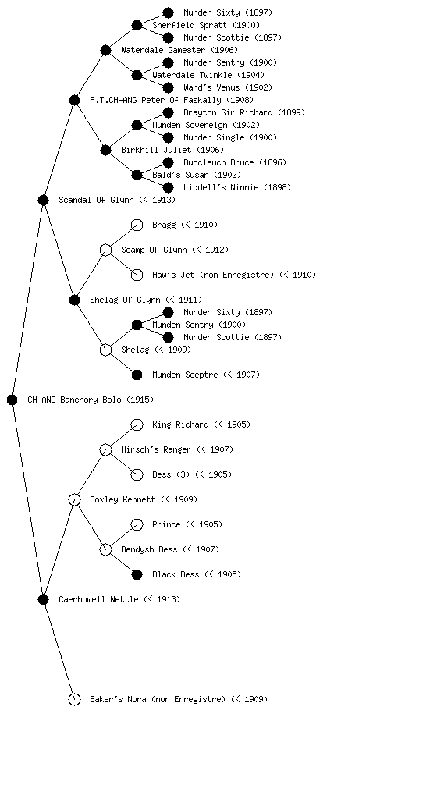
- Baker’s Nora (non Enregistre) (< 1909

Dual Champion Banchory Bolo, Christmas 1922 (pirmais foto augšā)
.
The Labrador was carefully bred up over time by the British sporting gentry from dogs brought back to England in the 19th century. These dogs were found to have unique characteristics which made them exceptional retrievers both on land and in the water.
Careful breeding also brought us English dual Champion Banchory Bolo (1915 - 1927).
.
Bolo marks are named after English dual Champion Banchory Bolo, who produced this mark in many of his puppies and future generations. The mark often goes away or is hidden by black hairs when the puppy grows up. Bolo marks are not considered a mismark. Many Labrador breeders see them as a sign of quality. Bolo marks are also linked to an excellent coat structure.
.
A small white spot, stripe or patch on the chest or Bolo pads (under the feet) are very common and do not lessen the quality of a Labrador, nor indicate it is not pure bred. To the contrary. A small white spot on the chest or under the feet is NOT considered a mismark and should not be penalised. (In most yellow Labradors the white spot is hardly visible, or not visible at all.)
.
Nell - A St. John's Dog circa 1856.
.
St. John's Dog with white spot
.
Labradors and Newfoundlands both trace their ancestry back to the now extinct breed known as a St. Johns Dog which usually had white markings on their feet, muzzle, and chests. Dogs with white markings are basically a genetic "throwback" to these ancestor's coloring. It often also means that they are closer to these ancestors.
.
Question: So most judges and Labrador Clubs accept Bolo marks, most judges don't even look for them, and generally there is no problem. What is your problem?
.
Answer: My problem is the lack of general breeding knowledge and specific knowledge about the Labrador Retriever in some Labrador Clubs. In the Netherlands, for instance, the board of the NLV, the Dutch Labrador Club, has always managed to fight the influence of the breeders. If a hundred breeders would come to the general meeting to conduct a case, the NLV board would see to it that some 120 "ordinary members" would be assembled to make sure the board had a majority. This has been going on for many years, and many breeders just gave up. They try to find their own way, some of them even moved to other countries, but the Dutch Labrador Club (NLV) has no support whatsoever from the Dutch Labrador breeders.
Would you believe that right now, as we speak, the board of the Dutch Labrador Club is preparing a lecture about coat mismarks, and that Bolo marks are mentioned as such? Of course, the board member who prepares the lecture is not an experienced Labrador breeder and she's not a professional or an expert when it comes to Labrador genetics, just like the rest of the board, and that is a problem. That is worrying me deeply, because the Dutch Labrador Club (NLV) is able to change the breeding policies - and probably will as a result of this lecture - which very well might lead to the fact that Dutch Labrador breeders won't be able to breed Labradors with Bolo pads in the near future.
I'm also worried that the Dutch Labrador Club might not be the only Labrador Club in the world with a board that (unofficially) excludes breeders from the board which otherwise contains of ignorant amateurs.
Question: So why should Bolo pads not be penalised?
Answer: First of all because Bolo pads are not a problem. They are hardly visible. So many people are seeing plastic surgeons nowadays -- nose jobs, lip jobs, belly jobs, they're all very normal and if you don't know what to give your relatives for their birthdays, the plastic surgeon is the answer. Surely their must be a spot that could be removed. I don't care what people do, but it's crazy to impose these ideas about "beauty" or "perfection" on dogs and dog breeders.
More important, we shouldn't throw out the baby with the bath water. Dual Champion Banchory Bolo was so much more than a dog with white marks under his feet and an excellent coat. He, for instance, is also one of the key dogs in tracing the transmission of the recessive chocolate colour gene to today's Labrador Retrievers.
In her book, Lady Howe wrote "Whilst I am writing about training and teaching to train I cannot leave out my Dual CH Banchory Bolo. I think it is only fair to such a great Labrador that he should be paid tribute to and be made known as a dog who could train and handle human beings, because through my intimate knowledge and personal devotion to him I certainly learnt more from him than he did from me."
Dual Champion Banchory Bolo became one of the most important dogs of his era. Lady Howe was a staunch believer in the dual purpose dog and her Bolo was the first to achieve this mark.
Genes are interconnected in a way that we're only beginning to understand. If the Bolo pads can survive for so many decades, so do the other, more important traits. If we get rid of the Bolo pads, because some amateurs in all their ignorance think that's a good idea, we might also get rid of extraordinary characters and skills in the process. You can isolate the Bolo pads in DNA tests, but you certainly can not isolate the extraordinary character and skills that come with it. That is a real danger and it worries me to death that some members of Labrador Club boards are not able to see this danger. I'm still very proud of Bolo pads in my dogs and I think that everyone who has a Labrador with Bolo pads should be proud too.
.

.

